Aim: To implement Clustering using Python

Software Required
- Python 3.x
- Jupyter Notebook
- Libraries: pandas, numpy, scikit-learn, matplotlib

Q1. What is Clustering?
Clustering is an unsupervised machine learning technique that groups similar data points into clusters based on inherent characteristics.
The primary objective is to ensure high similarity of data points within the same cluster and distinct dissimilarity between different clusters.

Q2. What is unsupervised learning?
Unsupervised learning is a machine learning technique that analyses and finds patterns in datasets without any labelled outcomes.
The algorithm explores the data independently to discover inherent groupings, structures, or hidden relationships within the information. Its primary goal is to model the underlying structure or distribution of the data for better understanding and insight.

Q3. What is K-Means Clustering?
K-Means is a popular unsupervised learning algorithm that partitions data into a predetermined number of clusters.
It aims to minimize the variance within clusters while maximizing the variance between different cluster groups. The algorithm works iteratively by assigning points to the nearest cluster centroid based on distance metrics.

Q4 What is a centroid?
A centroid is the geometric centre of a cluster, representing the average position of all data points within it. It is calculated by taking the mean of all feature values for points assigned to that specific cluster.

Q5. List applications of Clustering.
- Customer Segmentation
- Image Segmentation
- Document Classification
- Anomaly Detection
- Recommendation Systems
- Bioinformatics Analysis
- Social Network Analysis
- Market Research

Q6. Create clustering using the K-Means algorithm in Python.
Code:
import numpy as np
import pandas as pd
import matplotlib.pyplot as plt
from sklearn.cluster import KMeans
from sklearn.datasets import make_blobs
from sklearn.preprocessing import StandardScaler

X, y_true = make_blobs(n_samples=500, centers=4, cluster_std=0.90, random_state=50)

scaler = StandardScaler()
X_scaled = scaler.fit_transform(X)

inertia_values = []
K_range = range(1, 11)

for k in K_range:
kmeans = KMeans(n_clusters=k, random_state=42, n_init=10)
kmeans.fit(X_scaled)
inertia_values.append(kmeans.inertia_)

plt.figure(figsize=(12, 5))

plt.subplot(1, 2, 1)
plt.plot(K_range, inertia_values, 'bo-', markersize=8, linewidth=2)
plt.xlabel('Number of Clusters (K)', fontsize=12)
plt.ylabel('Inertia (Within-Cluster SSE)', fontsize=12)
plt.title('Elbow Method for Optimal K', fontsize=14)
plt.grid(True, alpha=0.3)
plt.xticks(K_range)

plt.axvline(x=4, color='red', linestyle='--', alpha=0.7, label='Optimal K=4')
plt.legend()

optimal_k = 4
kmeans_final = KMeans(n_clusters=optimal_k, random_state=42, n_init=10)
cluster_labels = kmeans_final.fit_predict(X_scaled)
centroids = kmeans_final.cluster_centers_

centroids_original = scaler.inverse_transform(centroids)

plt.subplot(1, 2, 2)
scatter = plt.scatter(X[:, 0], X[:, 1], c=cluster_labels, cmap='viridis',
s=50, alpha=0.7, edgecolors='black', linewidth=0.5)

plt.scatter(centroids_original[:, 0], centroids_original[:, 1],
c='red', marker='X', s=200, linewidths=3,
edgecolors='white', label='Centroids')

plt.xlabel('Feature 1', fontsize=12)
plt.ylabel('Feature 2', fontsize=12)
plt.title(f'K-Means Clustering (K={optimal_k}) with Centroids', fontsize=14)
plt.colorbar(scatter, label='Cluster Label')
plt.legend()
plt.grid(True, alpha=0.3)

plt.tight_layout()
plt.show()

unique, counts = np.unique(cluster_labels, return_counts=True)
for cluster, count in zip(unique, counts):
percentage = (count / len(cluster_labels)) * 100

centroid_df = pd.DataFrame(centroids_original,
columns=['Feature 1', 'Feature 2'])
centroid_df.index.name = 'Cluster'

from sklearn.metrics import silhouette_score
sil_score = silhouette_score(X_scaled, cluster_labels)

centroid_df.to_csv('kmeans_centroids.csv')

Output:
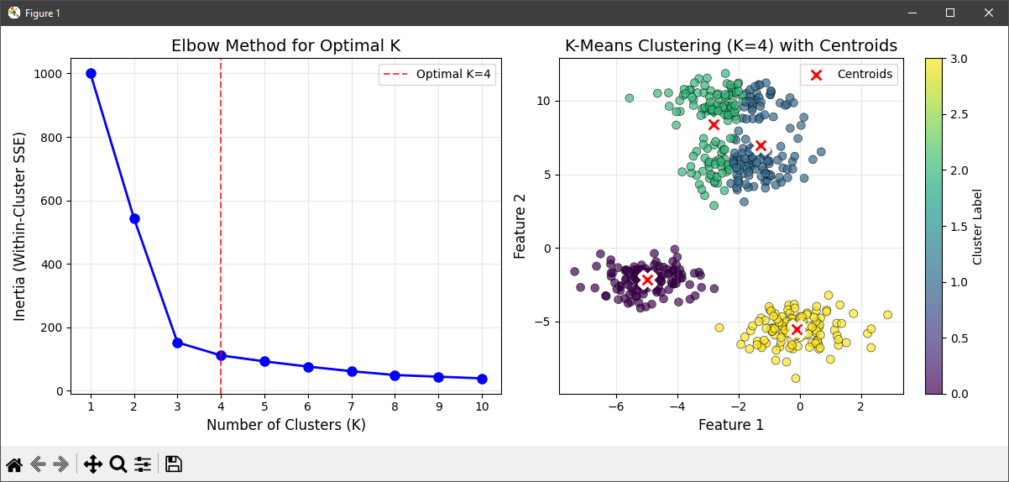

Conclusion:
Clustering effectively groups unlabelled data, revealing hidden patterns and structures for insightful data analysis and decision-making.

